Technical Parameters:
Voltage: 220V 50HZ
Power: 30W
Power: 1 * 12W led
Color: white light
Operating mode: self-propelled, DMX512, master-slave
DMX channel: 9 channels

LED Stage Lighting Operating Manual

10W Mini moving head beam light

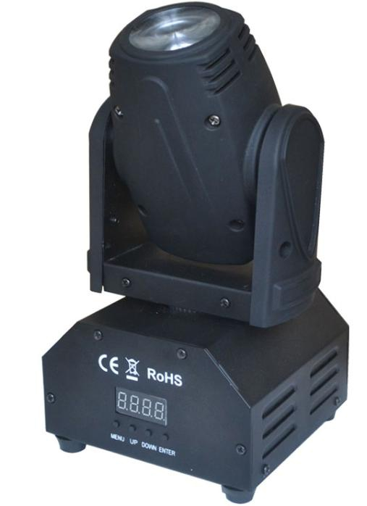

Function :
REST
REST

RESET
CH09-28
CH11

9 channel mode
CH13

28 channel mode
rPoF
rPoF

X motor is turning forward

rToF

rToF

y motor is turning forward

rTon

Y motor reversal

rPon

X motor reversal

rdoF

rdoF

Positive display
rdon

Reverse display
A001
001-512

Console control
Au01-02
Au01

Fast go mode
Au02

Slow go mode
SnOn-oFF
SnOn
Voice mode
SnOFF
Close Voice mode
dFoF
dFoF

Initialization parameters
dFon

Initialization parameters

512 channel description::

13 channel mode
Channel |  | Function
1 | 0-255 | Level
2 | 0-255 | Horizontal fine-tuning
3 | 0-255 | vertical
4 | 0-255 | Vertical fine-tuning
5 | 0-255 | speed
6 | 0-255 | Dimming
7 | 0-255 | Strobe
8 | 0-255 | Red dimming
9 | 0-255 | Green dimming
10 | 0-255 | Blue dimming
11 | 0-255 | White dimming
12 | 0-255 | 32-249 Self-propelled 2 250-255 voice control
13 | 0-255 | 165-200 reset

11 channel mode
Channel |  | Function
1 | 0-255 | Level
2 | 0-255 | Horizontal fine-tuning
3 | 0-255 | vertical
4 | 0-255 | Vertical fine-tuning
5 | 0-255 | speed
6 | 0-255 | Dimming
7 | 0-255 | Strobe
8 | 0-255 | Red dimming
9 | 0-255 | Green dimming
10 | 0-255 | Blue dimming
11 | 0-255 | White dimming

